EXERCISE 5
1. List all employees who hold the titles of "Senior Programmer" and "Multimedia Programmer".
SELECT f_name, l_name FROM employee_data WHERE title IN ('Senior Programmer', 'Multimedia Programmer');
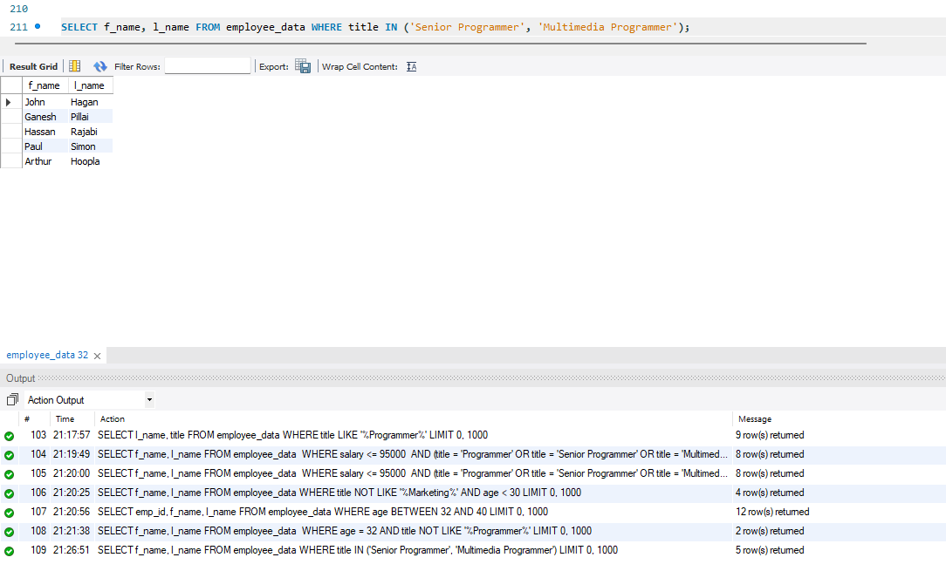
2. List all employee names with salaries for employees who draw between $70,000 and $90,000.
SELECT f_name, l_name, salary FROM employee_data WHERE salary BETWEEN 70000 AND 90000;
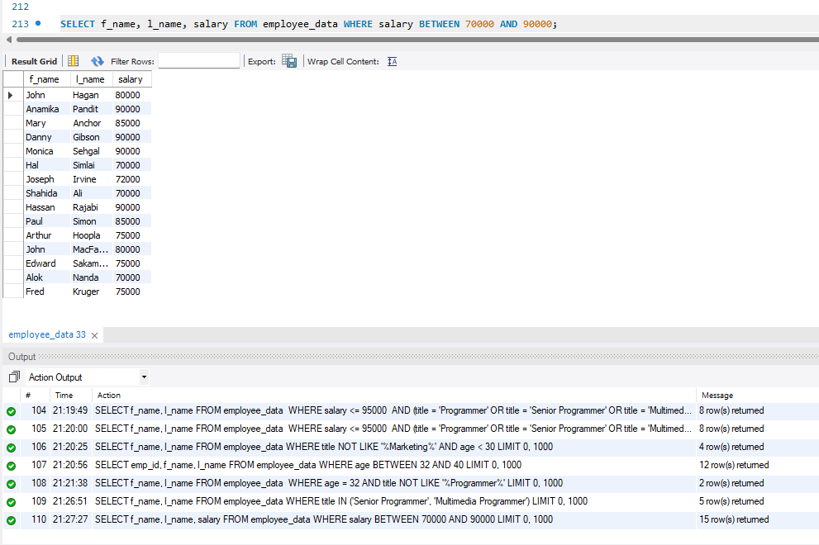
3. What will the following statement display?
SELECT f_name, l_name, title FROM employee_data WHERE title NOT IN ('Programmer', 'Senior Programmer', 'Multimedia Programmer');
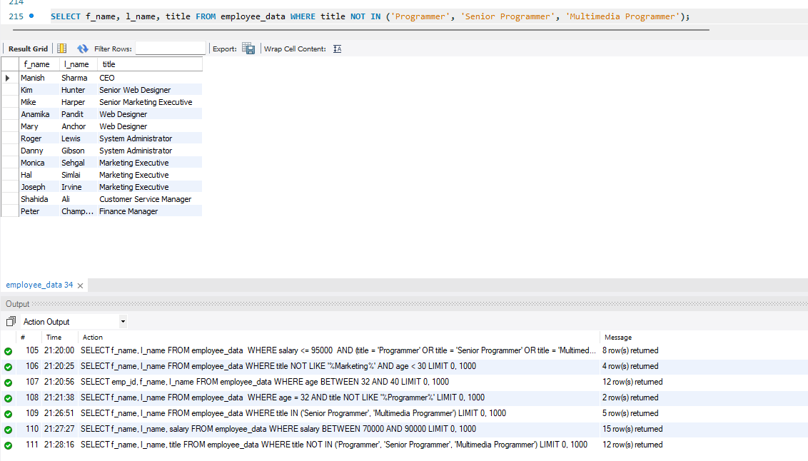
4. Here is a more complex statement that combines both BETWEEN and IN. What will it display?
SELECT f_name, l_name, title, age
FROM employee_data
WHERE title NOT IN ('Programmer', 'Senior Programmer', 'Multimedia Programmer')
AND age NOT BETWEEN 28 AND 32;
